Seminar 5

1. Implement a counter having the following transition graph (a decimal counter):

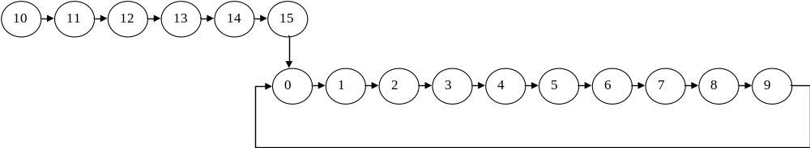

2. Same problem as above, but the self-correction and the self-initialization are done in a single clock cycle. Compare the solution with the previous one, in terms of number of integrated circuits.

3. Design using all the three types of Flip-Flops (JK, D and T) a sequential logic circuit (SLC) with the following properties:
- for X = 0 it generates at its output the numbers from 0 to 6 in ascending order
- for X = 1 it generates at its output the numbers from 6 to 0 in descending order
- the output Y = 1 for each configuration multiple of 3.

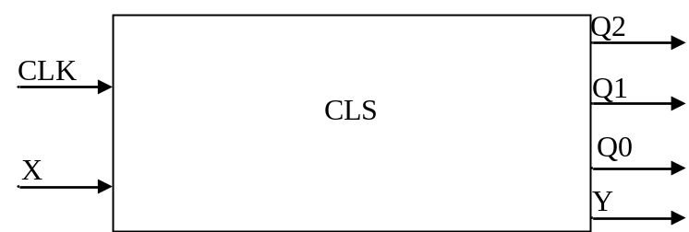

Hint: The next state depends on the current state and on the input (so it depends on X, Q2, Q1 and Q0), and the output depends only on the current state (so it depends on Q2, Q1 and Q0).

4. Design a sequential logic circuit (SLC) with the following properties:
a) it provides signal at its output at the apparition of even states between 0 and 7
b) it provides signal at its output at the apparition of odd states between 7 and 0
c) it signals the apparition of prime states from the 0-15 interval
d) it signals the apparition of multiple of 4 states from the 15-0 interval.

Hint: Draw the block scheme (the black box). Determine the number of inputs and outputs of the system. Determine which its working modes are. Determine on whom the outputs depend.

